CANADA
1/ The capital city of Canada is: Ottawa
2/ Canada borders with: The Pacific Ocean, The Artic O., The Atlantic O., 12 states of USA
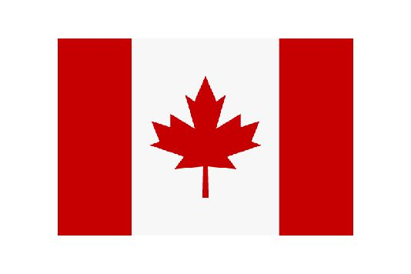
3/ Tha Canadian Flag contains: 2 red strips, 1 white strip, 1 red maple leaf
4/ Canada`s official head is: Queen E. II
5/ The largest city in Canada is: Toronto
6/ The well-know Canadian mountains are: The Rocky Mountains
7/Canada is the ...largest country in tha world: 2nd (in area)
8/ The most popular sport in Canada is: ice hockey
9/ Canada`s official language is: English and French
10/ Typical animals of Canada are: moose, bufallo, beaver, seal, walrus, wolf, lobster, ...
11/ Niagara Falls are: three waterfalls between Canada and the USA, the HorsesFalls lie mostly on the Canadian side
12/ Osoyoos is: Canada`s only desert with cacti and snakes
13/ Dinosaur Provincial Park: there are the most important fossild of dinosaurs (32 spices)
14/ National Park Wood Buffalo: there is the largest population of wild bison /ˈbaɪsən/
15/ Canada has about: 29 million people, most of them live near the US border
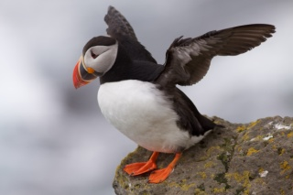
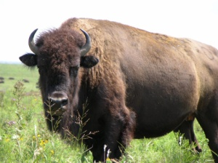
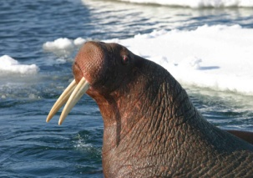
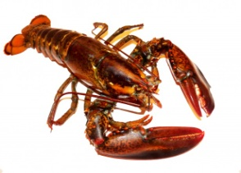
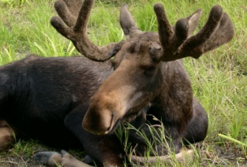
Moose /muːs/los lobster /ˈlɒbstə/humr puffin /ˈpʌfɪn/papuchalk walrus /ˈwɒlrǝs/mrož buffalo /ˈbʌfəˌləʊ/bizon
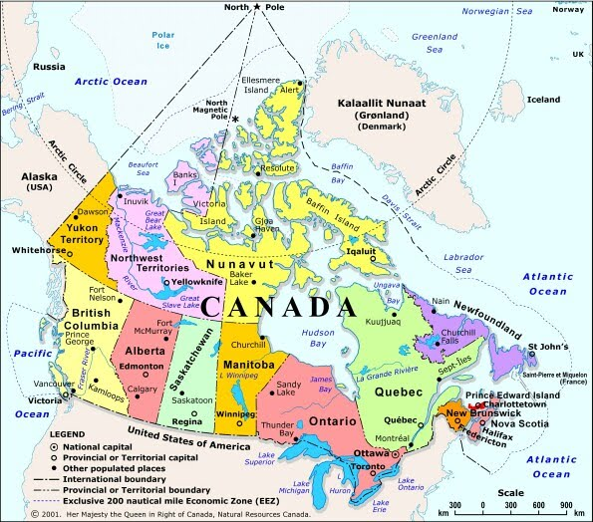
North American beaver /ˈbiːvə/ is
the national animal of Canada
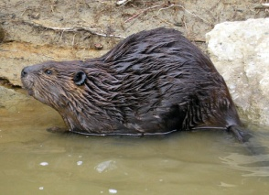

1/ The capital city of Canada is:  2/ What do you know about Niagara Falls?  3/ Say 6 typical animals of Canada.  4/ Alberta is: : the western province of Canada, there are for ex. Wood Buffalo Nation Park, Dinosaur Provincial Park, it is the only province in Canada - as well as one of the few places in the world - where almost do not live rats | 1/ Canada borders with:  2/ Canada`s official language is:  3/ What is the most popular sport in Canada?  4/ What is Osoyoos?
1/ The largest city in Canada is:  2/ What people live in the very north of Canada? How do they travel?  Eskimos, dog sleighs  3/ The well-know Canadian mountains are:  4/ How large in the area is Canada in the world? | 1/ Tha Canadian Flag contains:  2/ Canada´s official head is:  3/ What is Wood Buffalo?  4/ What do you know about Dinosaur Provincial Park?
